RESUME

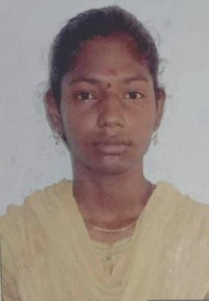

S . Gayathri ,
1/93 North street, P.Kaduvetti Paapakudi (po},
Udayarpalayam (TK).
Ariyalur DT.
Mobile :6385443792
Email id : lovelygayu3107@gmail.com

CAREER OBJECTIVE:

Seeking a challenging carrier in where I can design skills and academic knowledge will add value towards organization and personal growth.

EDUCATIONAL QUALIFICATION:

Qualification | Institution | percentage | Year of passing
Bsc Mathematics | Government arts college (Autonomous)  kombakonam ,  Thanjavur District. | 85% | 2021
HSC | Chandra Higher secondary school, Sethiyathopu | 78.33% | 2017-2018
SSLC | St.anthony's Higher  Secondary School,  Aranthangi. | 92.6% | 2015_2016

PERSONAL STRENGTH

- Confident and proactive
- Team player
- Friendly

COMPUTER QUALIFICATION

- Basic Computer knowledge
- MS- Office

PERSONAL DETAILS:

Name : S.GAYATHRI
Date of birth : 07.02.2002
Father Name : SELVAKUMAR
Gender : Female
Nationality : Indian
Religion : Hindu
Marital Status : Unmarried
Languages known : Tamil & English

DECLARATION

I hereby declare that above mentioned information is true to best of my knowledge and I bear the responsibility for the above particulars.

Yours faithfully,

( S.GAYATHRI)


